Chapter 12, Problem 62.

Using Fig. 12.68, design a problem to help other students to better understand how to use PSpice to analyze three-phase circuits.
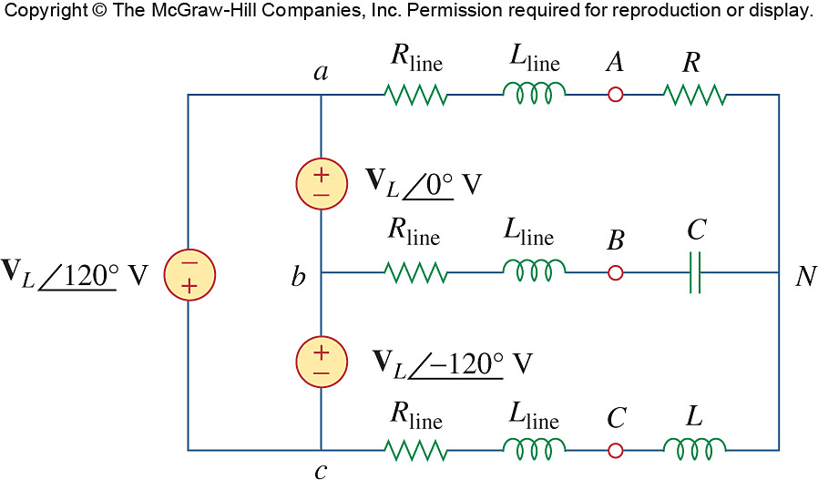

Figure 12.68
For Prob. 12.62.

